1. ***Title Page***

***Fitness Tracker App***

Project by: AJ Rallo, Shay Korhorn, and Anthony Streib

Date: 19 November 2023

Course Details: CS-150-01 Computer Programming for the Liberal Arts

* Pasteur Hall 002
* MWF 10:00 AM – 10:50 AM

In this course we explore many aspects of computer programming and solve problems using knowledge of computer programming and other necessary skills. In this course we use Python language in Jupyter Notebooks to learn the fundamentals of programming and apply them.

1. ***ABSTRACT***

In this project our task was to create an application based off a few specific topics, in this case our group chose to create a fitness tracker app considering all three of our group members are wrestlers who must consistently lose weight and track workouts and create goals for ourselves. Our project objectives were clear and concise, they consisted of allowing users to log their different types of workouts, users can log their progress, and users can generate fitness summaries. Our methodology consisted of importing math and date time modules to allow us the ability to use math, date, and time in our code. Then, we used class functions to create classes and exercises and workouts. Next, we allowed the user to upload data for their workouts and then the user can create goals for their weight, target weight, and calories burned. We then implemented a few different workouts such as running, cycling, and push-ups for the user to choose from. Then we implemented two key features in our code which are the while true and if statements for the user to choose their choice. Finally, for our project outcomes we got exactly what we were looking for and the user can add their weight, height, and age, and then the user can log their data and reach their fitness goals.

1. ***INTRODUCTION***

The purpose of this project is to choose from a few different topics and once you have decided, you must create an application for your specific topic. For our project we chose the fitness tracker, and the context behind our choice of the fitness tracker application is that all three of our group members are wrestlers who still wrestle on the Bellarmine Wrestling team. We, as wrestlers, must consistently and effectively cut weight throughout the season, therefore we must track our workouts and other data to reach our end weight goal. So, what better way to track your data than creating your own app that allows you to do so. The overall purpose of our fitness tracker application is for you to consistently track your progress in your fitness goals and in the end reach those said fitness goals. The problem our fitness tracker application addresses is the lack of reaching goals and quitting when getting into your fitness journey. It is okay to have slow progress because if you are disciplined and consistent, you can reach your goals. So, the overall goal of this application is to help not only wrestlers, but all athletes and people getting into fitness to achieve their goals and be proud of the way they look and feel.

1. ***METHODOLOGY***

Our methodology began with the different technology and tools we used. These tools and tech consisted of our laptops, jupyter notebooks, the python language, and everything we learned from the python language this semester. Our development process started off with importing math and date/time modules, then creating different classes using class functions, user can upload their data, and user can set fitness goals such as target weight. Then, we went into adding three different workouts to choose from such as running, cycling, and push-ups. Finally, we were able to implement two features that were important and key to our application. These features consisted of the ‘while true’ and ‘if’ statements. The overall planning was easy, although we ran into some trouble creating classes and had to start over from scratch. The code was tricky, yet we were able to use what we learned throughout the year and ask questions when we had them. Finally, we tested it a few times and had some type errors for our results that we swiftly fixed and refined to complete our project.

1. ***DESIGN AND IMPLEMENTATION***

The architecture and overall design of our project is well organized and designed this way, to be able to maximize the functionality of our application. We started with importing our key modules such as date/time and math. Then, we created our different classes using class functions. Next, we allowed the user to upload their data such as weight, height, and age, as well as added our three workouts for the user to choose from such as running, cycling, and biking. Furthermore, our two main features of this project were the while true and the if statements toward the end of the code. The ‘while true’ feature of our code allows the user to pick from our 4 different options such as log workout, calculate BMI, generate workout summary, and exit the program. Finally, the ‘if’ and ‘elif’ statements will allow the user to pick between their choices and use the program how they want to use it.

1. ***CHALLENGES AND SOLUTIONS***

We had multiple different challenges throughout the creation of our fitness tracker. The first problem was determining exactly what we would do in our code. Initially, we would write a bunch of different user inputs for a few different numbers for reps, time, and type of workout. But, after we figured out that it didn’t work, we decided to use class functions, which worked immensely. Our other main problem was one of our partners, we worked hard on our project and one of the group members failed to help in any way shape, or form. We learned that it is much more difficult to add all different coding techniques together as opposed to using one at a time. We learned about how hard the class functions are to use, and how extremely difficult it is to implement multiple different functions of code together. Initially, we thought this was going to be easy, but then it ended up taking hours of grinding for us to figure out what we wanted to do, and how to implement it.

1. ***RESULTS AND FINDINGS***

The project’s outcome was extremely successful, we ended up with a fully functional fitness tracker that managed to use 3 different types of exercises and manage to make them work with user input. We also managed to make a thing that logs your workout as well as when you worked out.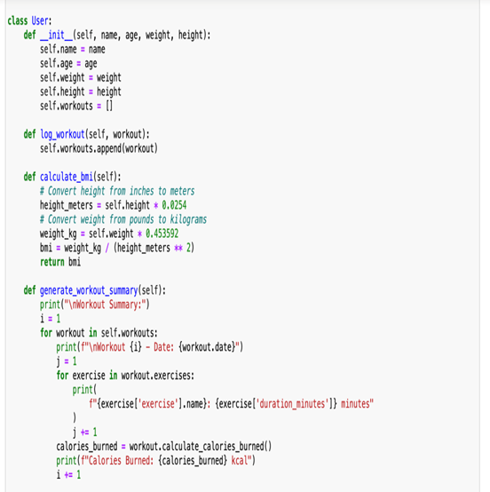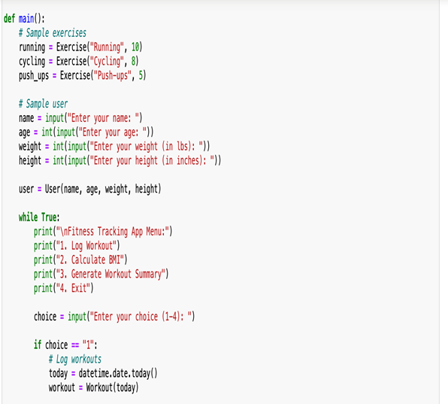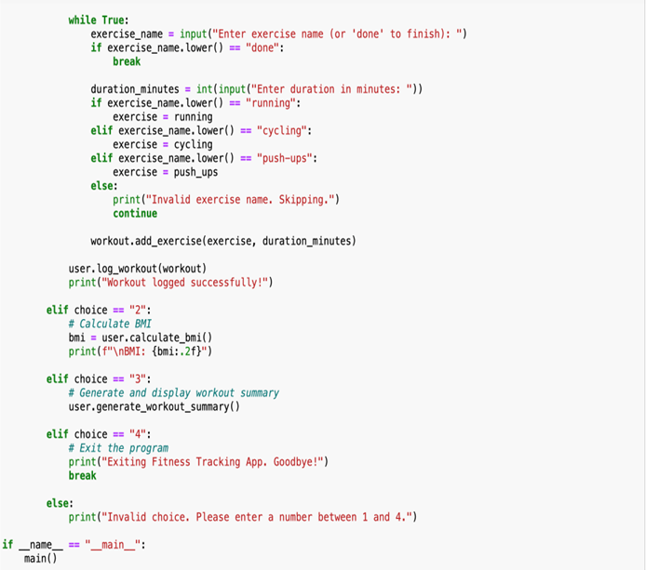

1. ***DISCUSSION***

This fitness tracker is significant because it will allow anybody who wants to use it to log their workouts and see how many calories burned, they worked out. It is very impressive that a few months ago we couldn’t code and at this point, three months later, we can create an entire fitness tracker. Some of the lessons learned were how to put different parts of code together and do it correctly and efficiently. This helped us to understand the different aspects of Python even better than we already did, as we learned about the versatility of them all, and how to implement them all.

1. ***CONCLUSION***

The main points of our report are the fundamentals of Python programming that we have learned throughout the year and being able to use them for our project. We were able to implement 10s of different functions and features of Python that we have learned over the past few months and apply them very well. We did this in a very organized way that managed to create a useful and sophisticated fitness tracker for different types of workouts and added many different options and features to it such as calories burned and logging workouts at a specific time. This has a very big impact on the American community as we need to work out more and this app can keep people in check and make them even excited to work out!

1. ***REFERENCES***

The only sources we used in this project were the different class notebooks we have written throughout this semester. We also managed to implement most of these notebooks together to create a fully functional and versatile fitness tracker.